LEVEL-1 DESCRIPTIVE STATISTICS

VARIABLE NAME N MEAN SD MINIMUM MAXIMUM
YEAR 7230 0.38 1.39 -2.50 2.50
MATH 7230 -0.54 1.53 -5.22 5.77
YEARSQ 7230 2.09 2.15 0.25 6.25

LEVEL-2 DESCRIPTIVE STATISTICS

VARIABLE NAME N MEAN SD MINIMUM MAXIMUM
BLACK 1721 0.69 0.46 0.00 1.00
HISPANIC 1721 0.15 0.35 0.00 1.00

LEVEL-3 DESCRIPTIVE STATISTICS

VARIABLE NAME N MEAN SD MINIMUM MAXIMUM
LOWINC 60 73.74 27.27 0.00 100.00

PartA
- Three-level model
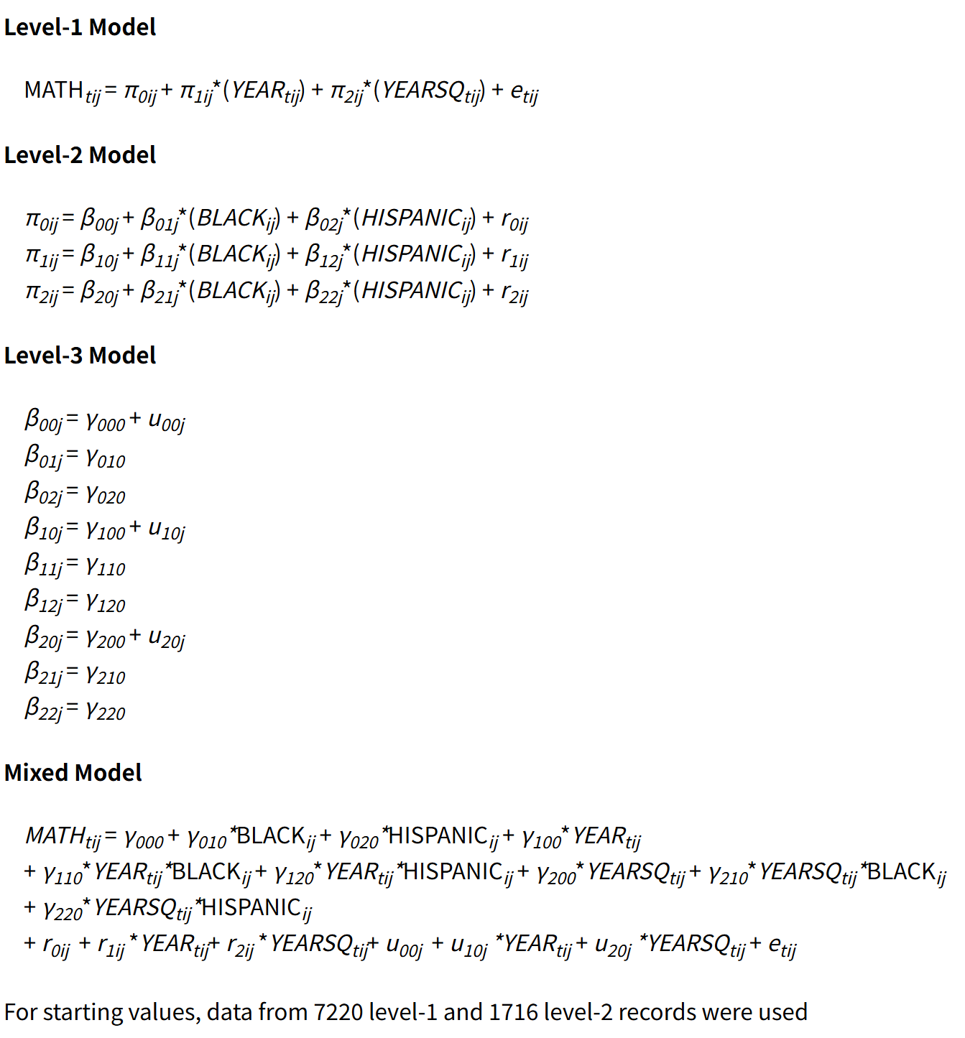

- see ethnic differences in achievement?
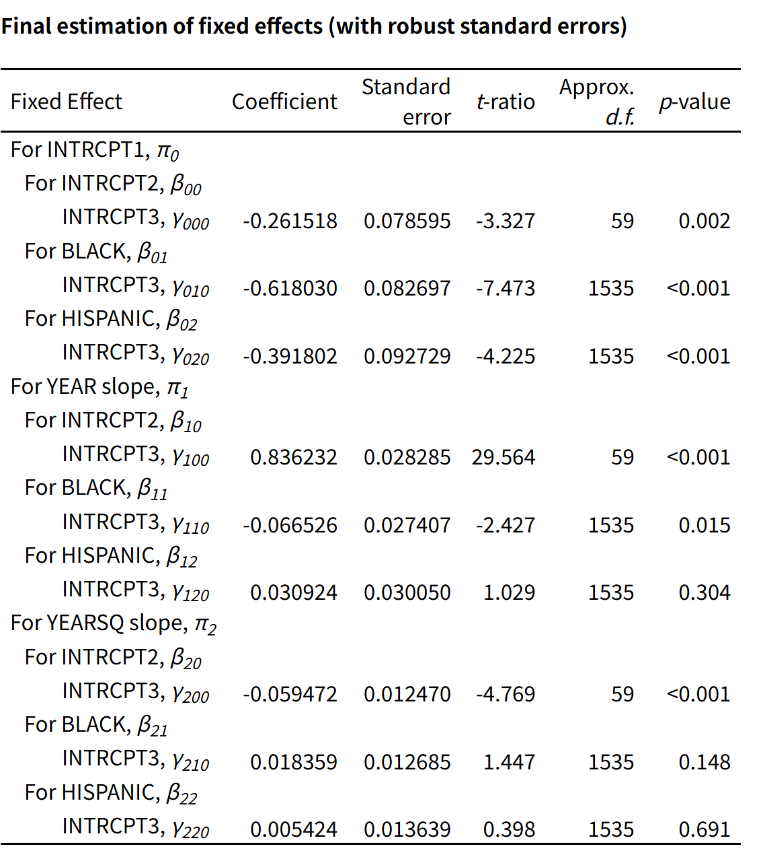
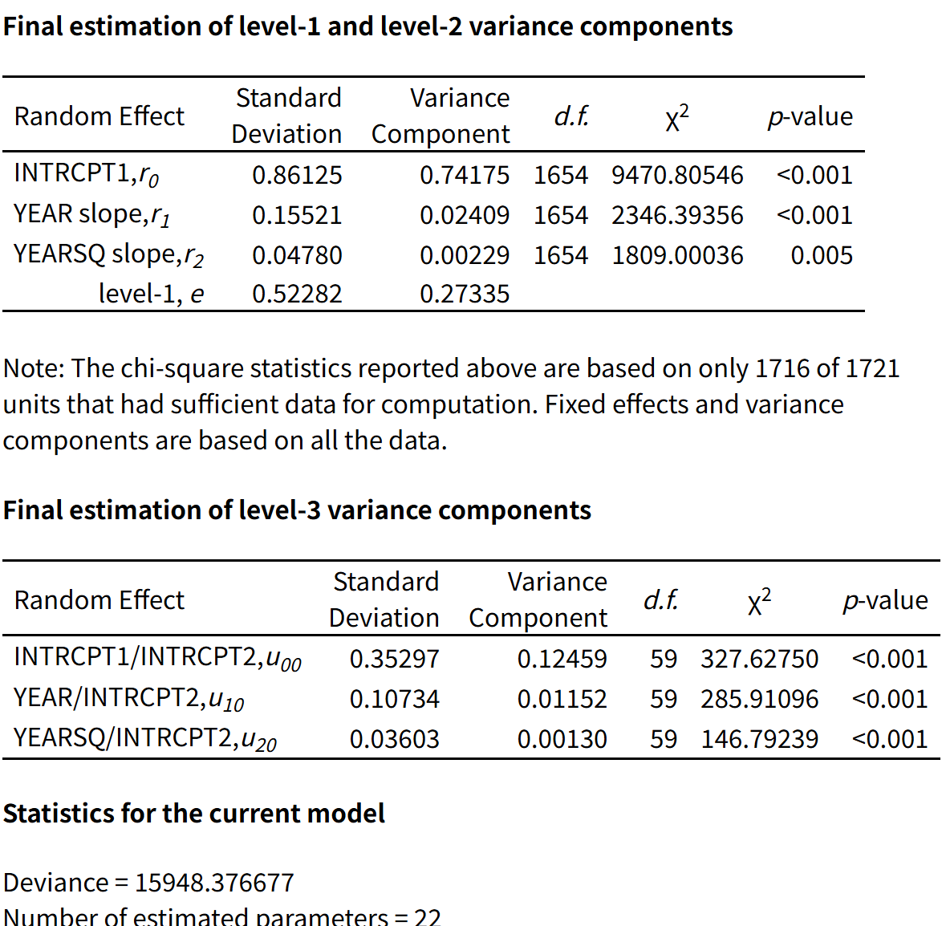

White students’ predicted math score at spring of first grade is -0.262. Black and Hispanic students begin significantly below white students, by about 0.618 and 0.392 points respectively.White students’ math achievement increases over time, but the negative quadratic term shows that growth slows over time. Black students have a significantly lower linear growth rate than white students, by about 0.067 points per year.Hispanic students’ linear growth rate is not significantly different from white students, same with Black and Hispanic quadratic differences.

- Create a model graph of the average trajectories

Math achievement increases over time, as indicated by the positive coefficient for YEAR (γ100= 0.797).
However, the negative coefficient for YEARSQ (γ200= -0.043) suggests that the growth rate slows down over time.
This implies a concave (inverted-U) trajectory, where achievement increases initially but at a decreasing rate.

4.Why only 3 random effects?
The model includes three random effects corresponding to the intercept, linear growth, and quadratic growth terms. Only these three random effects are included because the variance structure allows variability in these components across higher-level units.
The coefficients associated with race (BLACK and HISPANIC) are treated as fixed effects, which means their effects are assumed to be constant across contexts. Additionally, due to model specification constraints, not all coefficients can be modeled as random simultaneously.

5.Construct a 95% interval for intercept
Child-level white achievement: −0.2938±1.96×0.86125=(−1.95, 1.43)
School-level white achievement: −0.2615±1.96(0.35297)=(−0.95, 0.43)

For white students, within schools, most white students’ predicted initial math achievement falls in this range. The 95% plausible value interval for school-level white initial achievement means most schools’average initial achievement for white students falls in (−0.95, 0.43).

6.
Revised Level-3 model with LOWINC
$$β_{00j}=γ_{000}+γ_{001}LOWINC_{j}+u_{00j}$$
$$β_{10j}=γ_{100}+γ_{101}LOWINC_{j}+u_{10j}$$
$$β_{20j}=γ_{200}+γ_{201}LOWINC_{j}+u_{20j}$$

The key coefficient for the question is the effect of LOWINC on the linear growth rate
$$γ_{101}=−0.001640$$
This coefficient shows that schools with higher poverty concentration have slower math achievement growth. Each one-unit increase in LOWINC is associated with a decrease of about 0.00164 in the expected yearly growth rate, holding other variables constant. This effect is statistically significant, p = 0.004, so there is evidence that school poverty concentration predicts children’s math achievement growth rate.
The LOWINC effect on the quadratic term is small and not statistically significant, so there is not strong evidence that school poverty concentration predicts the curvature of growth.

7.
Compared with the model in Q2, the results change after controlling for school poverty concentration. In the original model, white students’ linear growth rate was approximately 0.836. After adding LOWINC, white students’ estimated growth rate increased to approximately 0.944. This suggests that school poverty concentration was masking some of the growth rate differences across schools.

The Black-white difference in linear growth becomes smaller after controlling for LOWINC. This suggests that part of the slower growth observed for Black students in the original model is related to the fact that Black students are more likely to attend schools with higher poverty concentration.

The quadratic term for white students also becomes more negative, changing from about -0.059 to about -0.071. This means that, after controlling for school poverty concentration, achievement growth still increases over time but decelerates somewhat more sharply.

Overall, adding LOWINC shows that school poverty concentration explains part of the ethnic disparities in math achievement growth, especially differences in growth rates. However, it does not fully eliminate ethnic differences in achievement.

partB
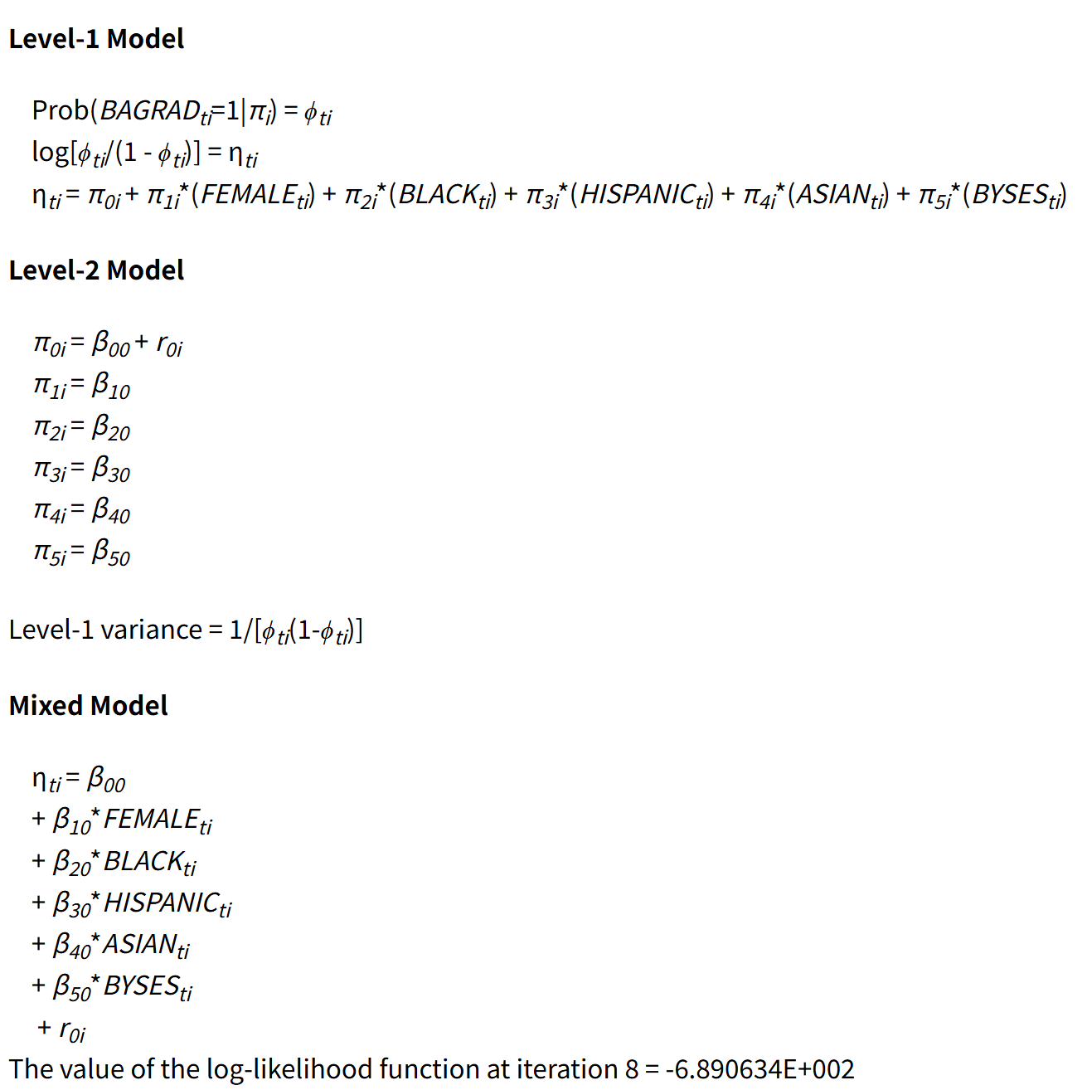
- Model, sampling model, link function, and interpretation

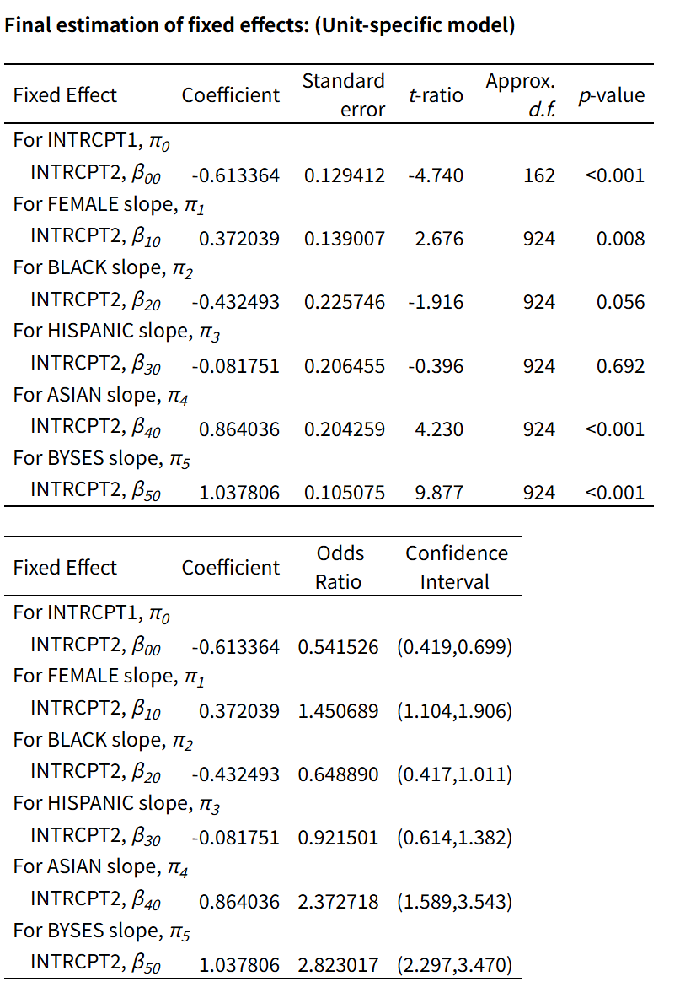

Predictor | Coefficient | Odds Ratio | Interpretation
Intercept | -0.631 | 0.532 | Baseline log-odds for a white male with BYSES = 0
FEMALE | 0.383 | 1.466 | Females have about 46.6% higher odds of BA graduation than males
BLACK | -0.446 | 0.640 | Black students have lower odds than white students, but this is not significant at .05
HISPANIC | -0.084 | 0.919 | Hispanic students do not differ significantly from white students
ASIAN | 0.887 | 2.427 | Asian students have much higher odds than white students
BYSES | 1.067 | 2.905 | A one-unit increase in BYSES nearly triples the odds of BA graduation

- Predicted probabilities
Use the logistic transformation
$$p=\frac{e^{η}}{1+e^{η}}$$

A.White male
$$η=−0.631$$

$$p=\frac{e^{−0.631}}{1+e^{−0.631}}=0.347$$

Predicted probability = 0.347

- white female
$$η=−0.631+0.383=−0.249$$
$$p=\frac{e^{−0.249}}{1+e^{−0.249}}=0.438$$

Predicted probability = 0.438

- Hispanic male
$$η=−0.631−0.084=−0.716$$
$$p=\frac{e^{−0.716}}{1+e^{−0.716}}=0.328$$
Predicted probability = 0.328

- Hispanic female
$$η=−0.631+0.383−0.084=−0.333$$
$$p=\frac{e^{−0.333}}{1+e^{−0.333}}=0.418$$
Predicted probability = 0.418

- The female coeffient is constant on the log-odds scale, but it is not constant on the probability scale.
For white students, 0.438−0.347=0.091
For Hispanic students,0.418−0.328=0.090

being female increases the predicted probability of college graduation by about 9.1% for white students and about 9.0% for Hispanic students, which are similar, but not the same as the logistic transformation is nonlinear.

4.Catholic school effects
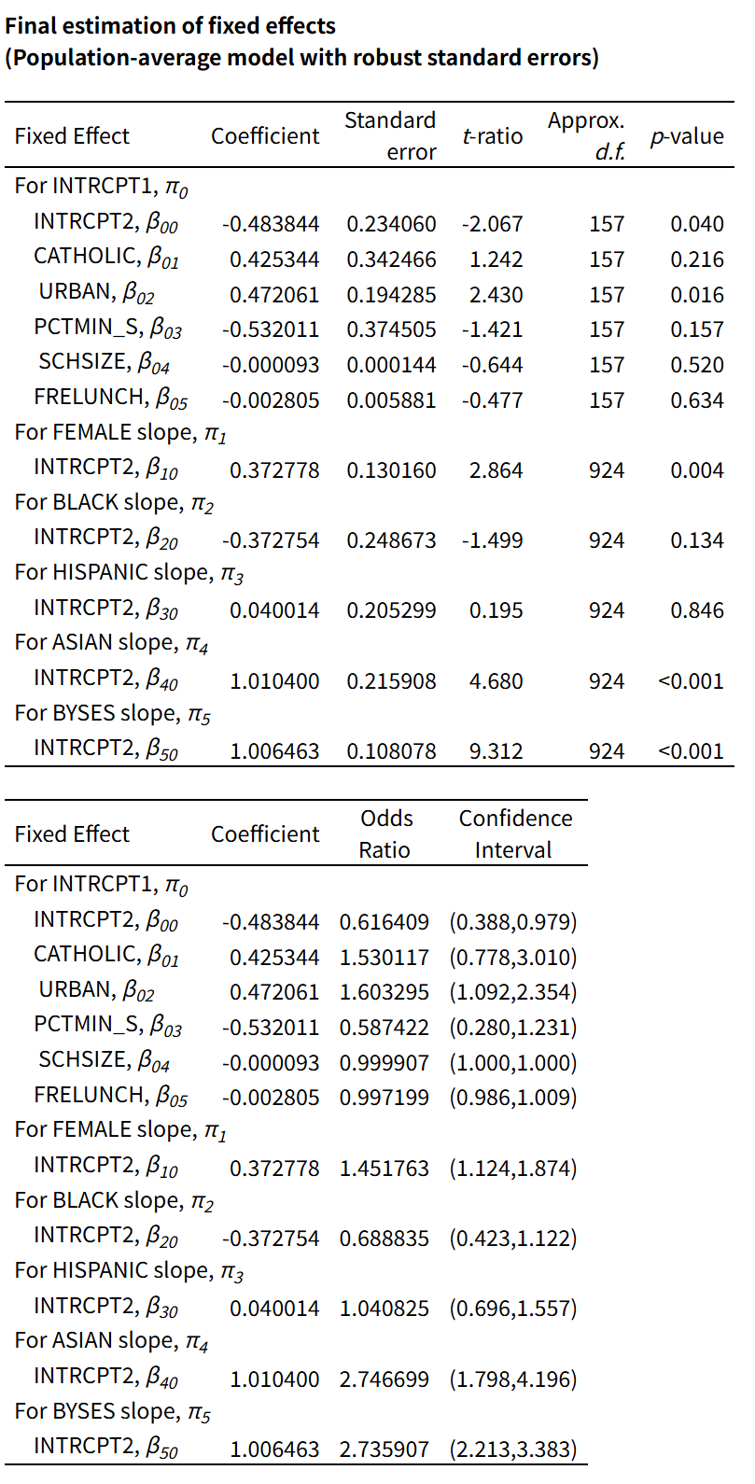
The coefficient for CATHOLIC is positive (β= 0.425), indicating that attending a Catholic school is associated with higher odds of college graduation. Specifically, the odds of graduating from college are about 1.53 times higher for students attending Catholic schools compared to non-Catholic schools, holding other variables constant.
However, this effect is not statistically significant (p = 0.216), and the confidence interval includes 1. Therefore, we cannot conclude that attending a Catholic school has a statistically significant effect on college graduation rates after controlling for school-level characteristics.
5.
College graduation is strongly associated with student characteristics.Female students, Asian students, and students with higher BYSES have higher predicted odds of earning a BA degree. In the schoole level model, attending a Catholic high school has a positive estimated association with college graduation, but the effect is not statiscally significant.
Upon the population average model, the coefficient for catholic is 0.425, and the odds ratio is 1.53, which means that students attending Catholic school are estimated to have about 1.53 times the odds of college graduation compared to students attending non-Catholic schools, holding the school-level controls constant. However, the effect is not statiscally significant, so it should be interpreted cautiouslu.
For a reference student with all other predictors set to 0, the predicted probability in a non-Catholic school is p0=0.381. For the same student in a Catholic school, p1=0.485. and the change is 0.104.
So attending a Catholic high school is associated with 10.4% increase in the probability of eventually obtaining a BA degree for this reference student. Again, beacuse the Catholic coefficient is not statiscally signifant, this should not be interpreted as strong evidence of a Catholic school effect.

